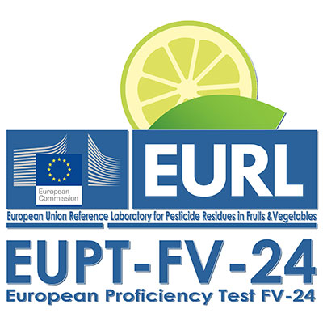

EUPT-FV24 CALENDAR

ACTIVITY | DATE
Registration period | 6th December 2021-11th February 2022
Specific Protocol published on the Web site. | 21st February 2022 at the latest
Selection of the scope | 24th February – 7th March 2022
Sample distribution. | 7th March 2022
Deadline for receiving sample acceptance | 11th March 2022
Deadline for receiving results | 4th April 2022
Filling in additional information, if necessary. | 5th– 8th April 2022
Preliminary Report: (containing preliminary assigned values  and z scores) | April 2022
Final Report distributed to the Laboratories. | August 2022

